NAME: ARCHANA DEVI.P
REG NO: 192521192
COURSE: DESIGN ANALYSIS OF ALGORITHM
CODE: CSA0613
ASSIGNMENT: CO5_AT_2

Q7. Permutation Generation Problem
Write a pseudocode to generate all possible permutations of a given set of elements using
Backtracking. Clearly define inputs (set of elements) and output (all permutations). Design a
complete algorithm with proper swapping and backtracking steps. Use loops and recursive
calls effectively. Present the pseudocode in a clear and structured format. Ensure all
permutations are generated without repetition.

1. Aim
To generate all possible permutations of a given set of elements using the Backtracking technique.
2. Problem Statement
Given a set of n elements, generate all possible arrangements (permutations) of those elements using Backtracking.
The algorithm should:
- Accept a set or list of elements as input.
- Generate every possible ordering of the elements.
- Use swapping to place elements in different positions.
- Use recursion to explore all possible arrangements.
- Use backtracking to restore the original arrangement after each recursive call.
- Avoid generating duplicate permutations when the input contains unique elements.

3. Input and Output Definition
Input
A set or list containing n distinct elements.
Example:
[1, 2, 3]
Output
All possible permutations of the input elements.
Example:
1 2 3
1 3 2
2 1 3
2 3 1
3 2 1
3 1 2
For n distinct elements, the total number of permutations is:
n!
For example:
- 3 elements → 3! = 6 permutations
- 4 elements → 4! = 24 permutations
- 5 elements → 5! = 120 permutations
4. Backtracking Approach
The algorithm generates permutations by fixing one position at a time.
Working Steps
- Start from the first position.
- Swap each element with the current position.
- Recursively generate permutations for the remaining positions.
- After returning from the recursive call, swap the elements back.
- This restoration step is called Backtracking.
- Continue until every possible arrangement is generated.
Backtracking Flow
Start
↓
Choose an element for the current position
↓
Swap elements
↓
Recursively solve remaining positions
↓
Restore original arrangement
↓
Try next possible element

5. Pseudocode
ALGORITHM GeneratePermutations(A, start, end)
IF start = end THEN
PRINT A
RETURN
END IF
FOR i ← start TO end DO
SWAP A[start] AND A[i]
GeneratePermutations(A, start + 1, end)
SWAP A[start] AND A[i]
END FOR
END ALGORITHM
Main Program
START
INPUT list A
n ← LENGTH(A)
GeneratePermutations(A, 0, n - 1)
STOP
6. Explanation of Pseudocode
The recursive algorithm works by fixing elements at each position.
For the input:
[1, 2, 3]
Level 1
Fix an element at position 0:
1 _ _
2 _ _
3 _ _
Level 2
For each choice at position 0, fix one of the remaining elements at position 1.
For example:
1 2 _
1 3 _
Level 3
The final position is automatically filled with the remaining element:
1 2 3
1 3 2
The process continues recursively until all permutations are generated.

6. PROGRAM:
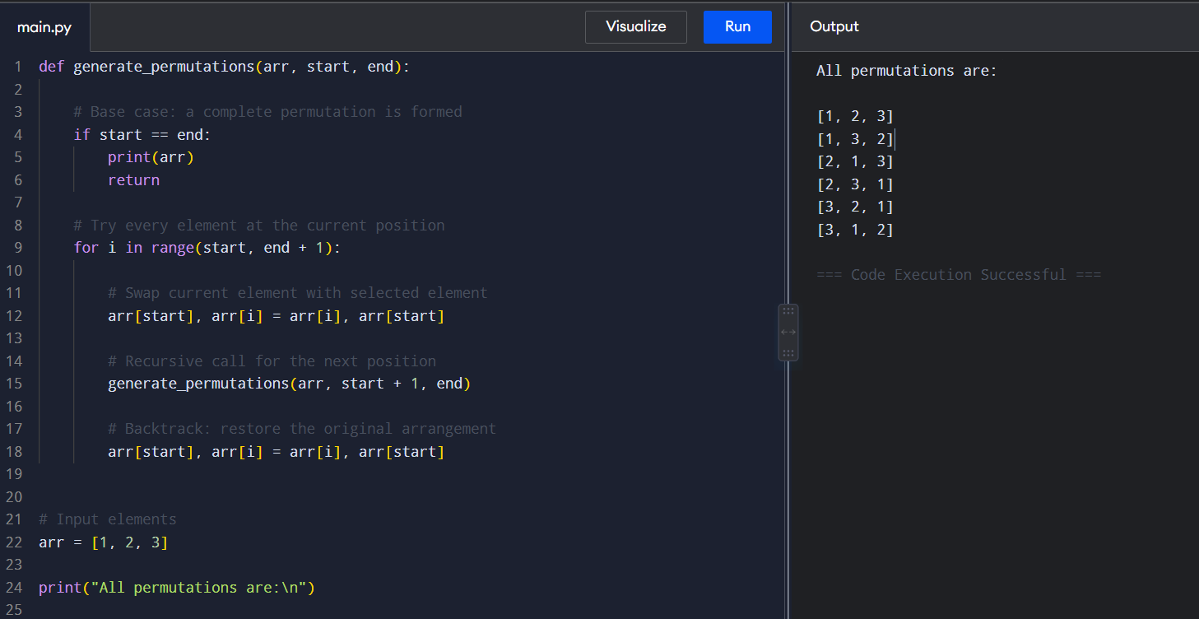
9. Example of Backtracking
Consider:
[1, 2, 3]
First Swap
[1, 2, 3]
Fix 1 at the first position.
Generate:
[1, 2, 3]
[1, 3, 2]
Backtrack
Restore the array:
[1, 2, 3]
Second Swap
Swap 1 and 2:
[2, 1, 3]
Generate:
[2, 1, 3]
[2, 3, 1]
Backtrack Again
Restore the original arrangement:
[1, 2, 3]
The same process continues until every possible permutation has been generated.
10. Algorithm
FUNCTION GeneratePermutations(A, start, end)
IF start = end THEN
DISPLAY A
RETURN
END IF
FOR i = start TO end DO
SWAP A[start] WITH A[i]
CALL GeneratePermutations(A, start + 1, end)
SWAP A[start] WITH A[i]
END FOR
END FUNCTION
BEGIN
A ← [1, 2, 3]
n ← LENGTH(A)
GeneratePermutations(A, 0, n - 1)
END
11. Correctness of the Algorithm
The algorithm is correct because:
- At each recursive level, one element is fixed in the current position.
- The loop tries every available element for that position.
- The recursive call generates all possible arrangements of the remaining elements.
- When the recursion reaches the final position, a complete permutation is produced.
- The swap-back operation restores the previous state before exploring the next possibility.
- Since every possible element is considered at every position, all possible permutations are generated.
For an input containing n distinct elements, the algorithm produces exactly:
n! unique permutations.
12. Time and Space Complexity
- Time Complexity
The number of permutations for n elements is:
n!
Therefore, the time complexity is:
O(n × n!)
The algorithm generates n! permutations, and printing or copying each permutation requires O(n) time.
- Space Complexity
The recursive function uses a recursion stack of depth n.
Therefore:
O(n)
auxiliary space is required.

13. Advantages of Backtracking
- Generates all possible permutations systematically.
- Uses recursion effectively.
- Requires relatively small additional memory.
- The swap operation allows efficient modification of the array.
- Backtracking restores the original state after each recursive exploration.
- Suitable for solving combinatorial problems.
14. Result
- The permutation generation algorithm was successfully implemented using the Backtracking technique. The program generated all possible unique arrangements of the given elements. The swapping operation was used to place different elements at each position, while backtracking restored the array after each recursive call.
- For the input [1, 2, 3], the program successfully generated all 3! = 6 possible permutations.
15. Conclusion
- The permutation generation problem demonstrates the use of recursion and backtracking for exploring all possible arrangements of a set of elements. The algorithm fixes one element at each position and recursively generates permutations for the remaining elements.
- Swapping is used to explore different arrangements, while the backtracking step restores the original arrangement after each recursive call. This ensures that every possible permutation is explored systematically.
- The algorithm successfully generates all n! permutations for a set of n distinct elements without repetition.

